Game Design Document

Fill up the following document

1. Write the title of your project.

Saving the earth

1. What is the goal of the game?

Saving the earth been destroyed by asteroids.

1. Write a brief story of your game.

In this game the player should save the earth by destroying asteroids

Whenever the player destroys the asteroids, he will receive coins and whenever the player touches the asteroids, he will use his life’s. They are 3 life’s for the player to save the earth. If the asteroids hits the earth the game is over.

1. Which are the playing characters of this game?

* Playing characters are the ones who respond to the user based on the input from the user.
* Cars, monkeys, dinos, wizards, etc., are the playing characters in the game.

|  |  |  |
| --- | --- | --- |
| Number | Character Name | What can this character do? |
| 1 | astronaut | Save the earth been destroyed by earth. |
| 2 | earth | It keeps on routating. |
| 3 | asteriods | It tries to hit the earth. |
| 4 |  |  |
| 5 |  |  |
| 6 |  |  |
| 7 |  |  |
| 8 |  |  |

1. Which are the Non-Playing Characters of this game?

* Non-Playing characters are the ones that don't have an action or behavior when the user interacts with the game.
* Hurdles, stones, bananas, coins, etc., are non-playing characters in the game.

|  |  |  |
| --- | --- | --- |
| Number | Character Name | What can this character do? |
| p | coins |  |
| 2 | guns | Used to destroy the asteroids. |
| 3 | bombs | Used to destroy the asteroids. |
| 4 |  |  |
| 5 |  |  |
| 6 |  |  |
| 7 |  |  |
| 8 |  |  |

Draw your imagination of this game. What does this game look like?

* Draw the game either on your computer or on paper.
* Add images of the game scenes to show each of the playing and non-playing characters at least once.

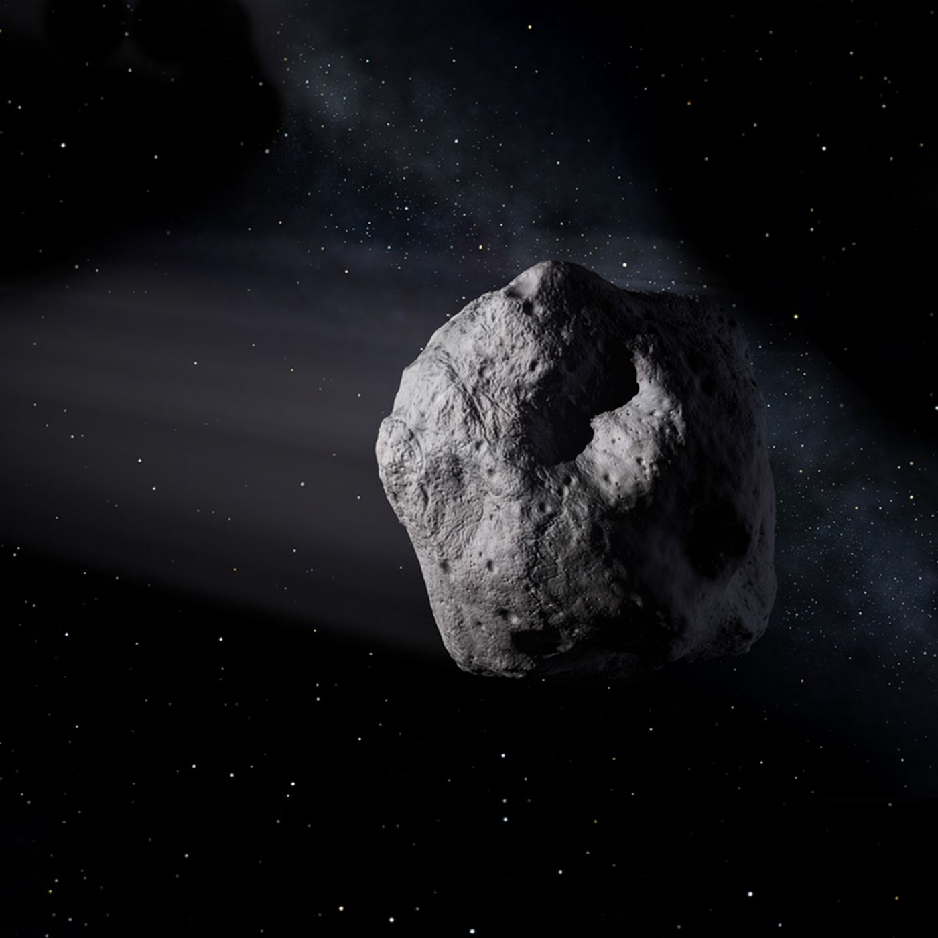

Astroids

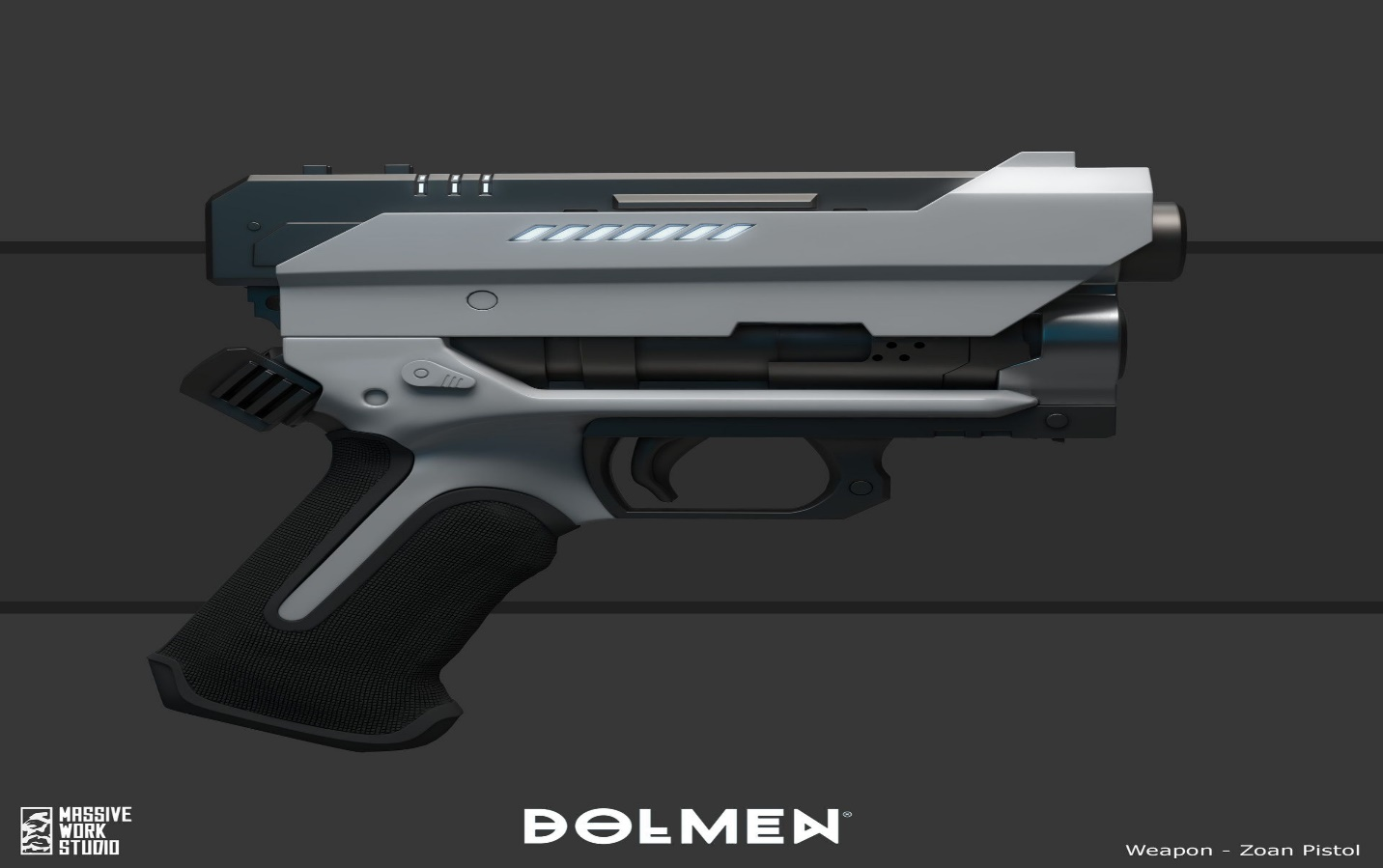

Space guns

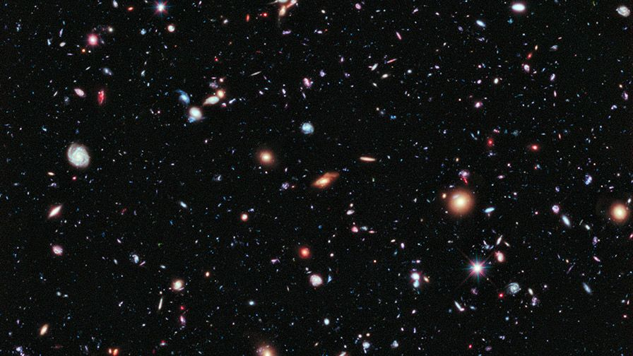

Space

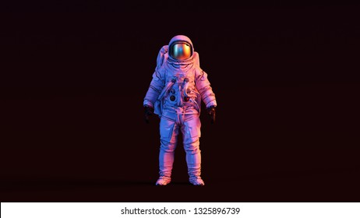

astronuts

How do you plan to make your game engaging?

Answer = P5 editor